Hvaleyravatn SS1
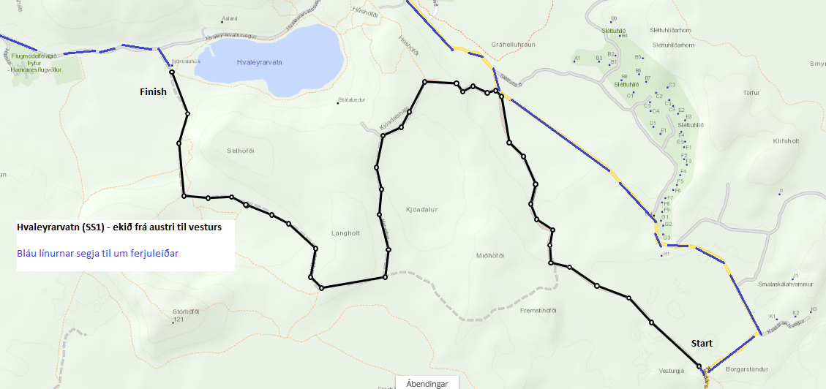

Djúpavatn SS2/SS17
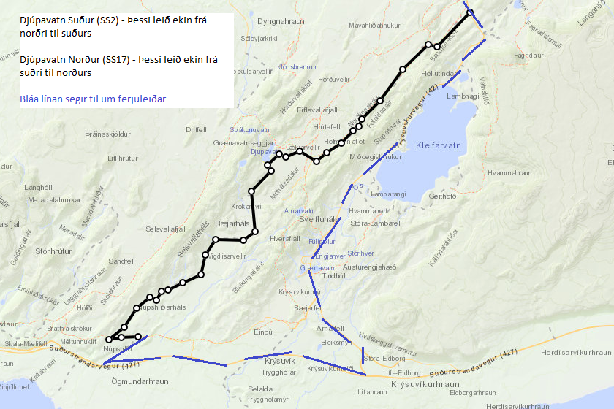

Arnastapi / Ólafsvík SS5/SS7
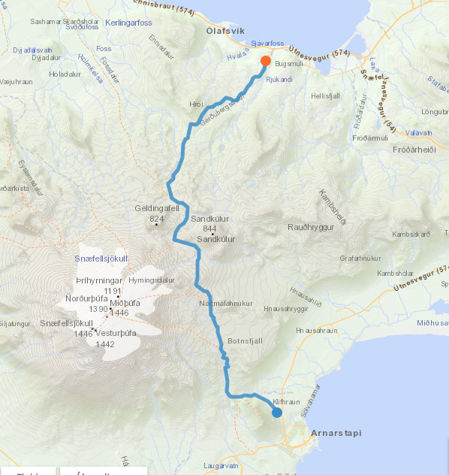

Prestahraun SS6/SS8
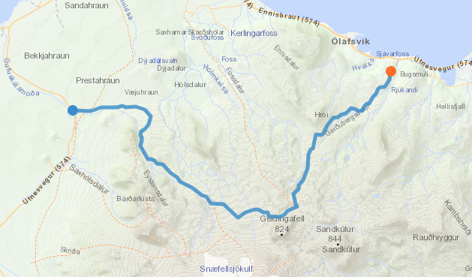

Berserkjahraun SS9/SS10
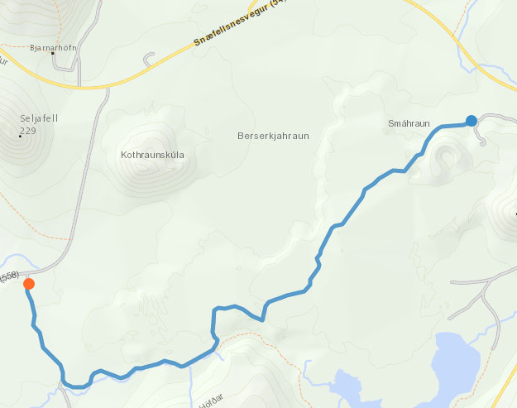

Skíðsholt SS11/SS12
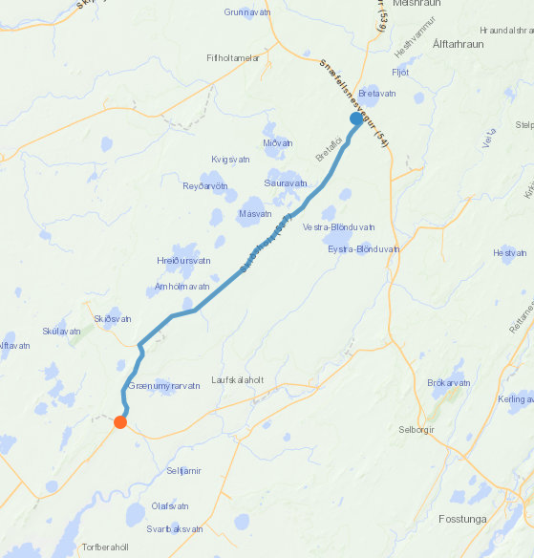

Kaldidalur SS13
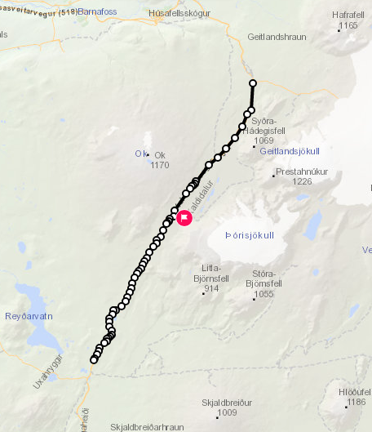

Skjaldbreiðavegur SS14/SS15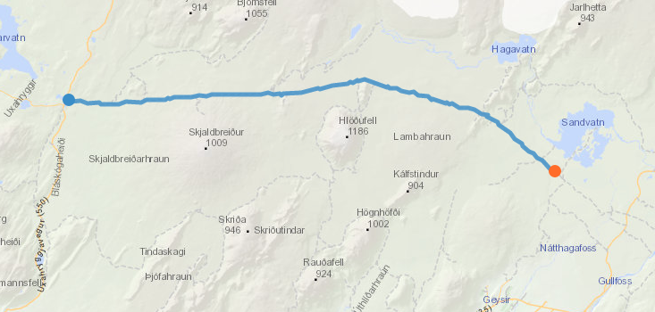

Tröllháls SS16